eptember 2, 2013
FOR IMMEDIATE RELEASE
September 2, 2013

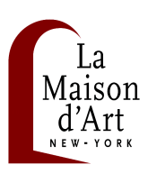
“BEHIND THE SCAR” ART EXHIBIT

September 18 through October 31, 2013 - Opening Reception: Wed. Sept. 18th, 6:30-9PM

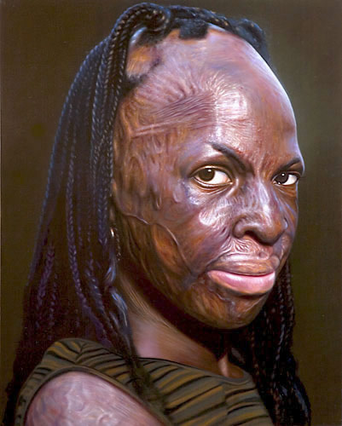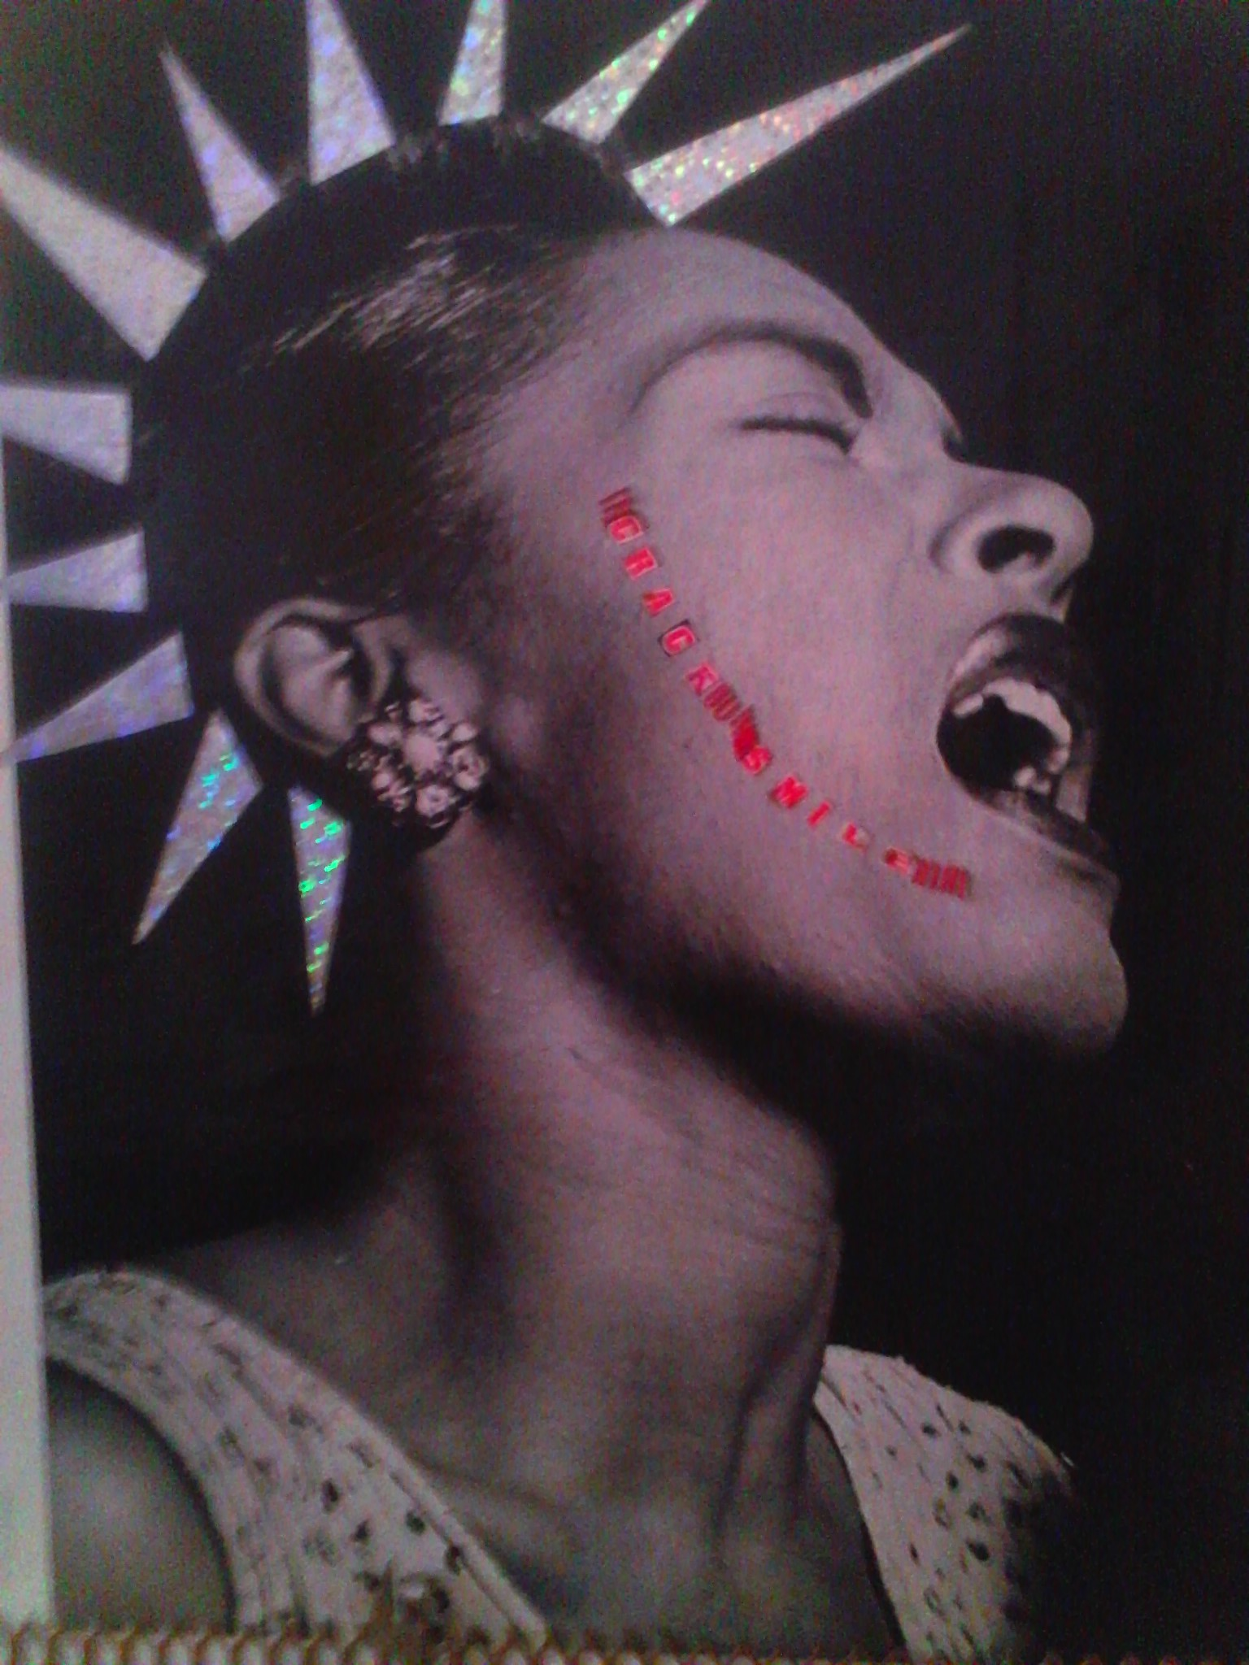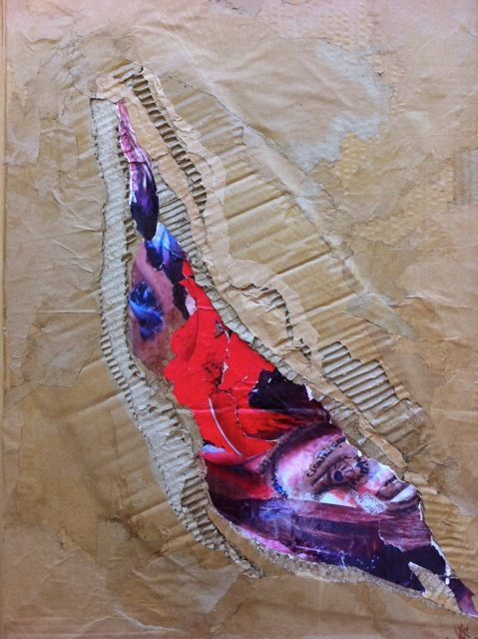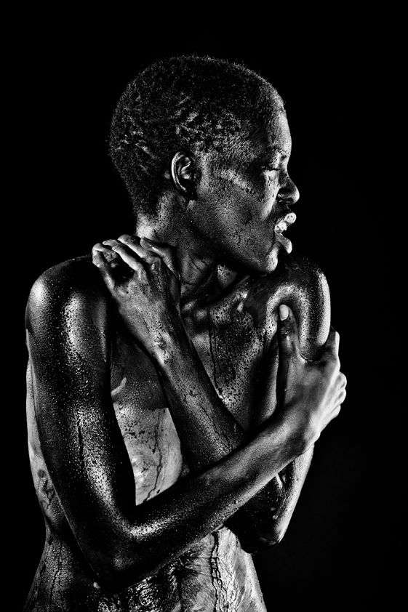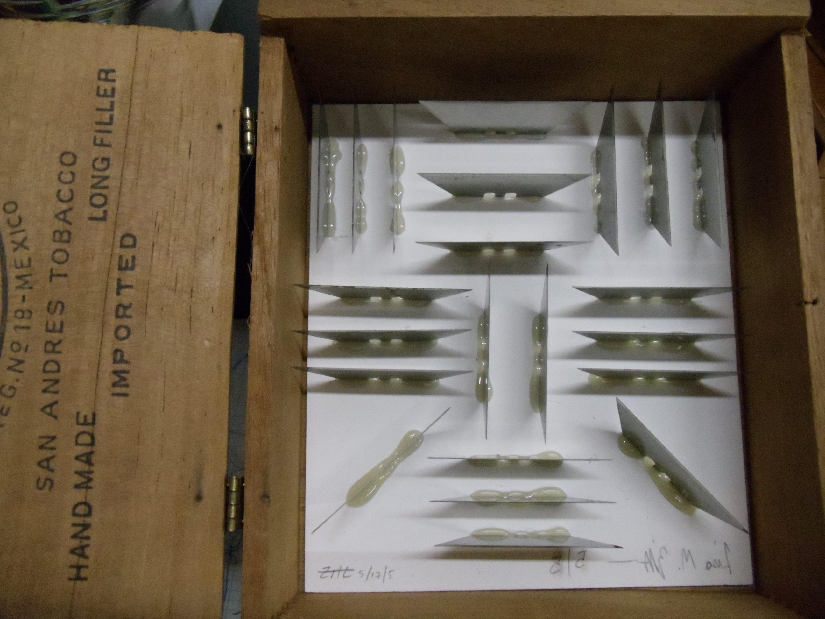

New York, NY – La Maison d’Art Gallery is pleased to present a group exhibition “ BEHIND THE SCAR” from September 18 through October 31, 2013, featuring the following artists: Doug Auld, Jeremiah Drake, Dominique Jaussein,, Vallée Stoffler, Lisa Zilker.

“Behind the Scar” is about all of us, walking the path of Life with scars on our body, in our soul, in our hearts. Some of us have the “privilege” to be able to hide them, some others must carry them for the world to see, look away, assume, and judge without understanding. Diseases, accidents, violence, society, emotions … All these wounds our body and soul have to work so hard to heal. Even if the body has a natural way to heal and create a scar over a wound, A Trace always remains.

A Mark we can decide to ignore or to change its whole meaning.

How do we process it? Where do we go from there? What triggers our heart and soul to fight, get back up and change things? Art has its mysterious way to heal, to give powerful tools to an artist to move Society and force us to deal with, to see, to process what we sometimes refuse to look at and burry inside of us.

The artists have used Art to expose, to heal, to process, to advocate for what’s Behind the Scars: Painting portraits of burn survivors to document their visual facts while interpreting the less tangible aspects of inner beauty and personal character (Doug Auld), Advocating, helping, and honoring victims of domestic attacks by giving them a new life (Jeremiah Drake), Through a woman’s anger and pain of her social and poverty conditions (Dominique Jaussein), Beating Breast cancer and pouring the nausea of what surrounds it into a wound (Vallée Stoffler), Boxing our pains and making personal decision to inflict it on ourselves, physically or emotionally (Lisa Zilker).

Art is Healing … Discover “Behind The Scar” Artists who dare to show you through their talent.

About La Maison d’Art Gallery:
La Maison d’Art Gallery is a private art gallery where art is an overarching feature. This concept is reflected in a dynamic program of exhibitions, music, dance and cultural events throughout the year. Exhibitions organized by La Maison d’Art have encompassed all the visual arts: painting, sculpture, drawing and printmaking, photography, architecture and decorative arts, video, film, and performance. In addition to producing its own exhibitions, La Maison d’Art Gallery welcomes guest curators.
La Maison d’Art Gallery, 259 West 132nd Street, New York, NY 10027 - Tel: 718/593-4108, Fax: 917/210-3262
E-mail: info@lamaisondartny.com
Hours:
Wed-Fri: 4–7 pm / Sat-Sun: 11 am–5 pm / Monday, Tuesday and major holidays: Closed

